**Lab-1 Assignment**

**Submitted by:**

**Sudeep Timalsina**

**Student ID: 23036857**

**Submitted to:**

**Professor: Nawaz Chowdhury**

**Subject: Web Development 2**

**Course code: CSD213**

Honesty Statement: “I declare that this submission is my own work in compliance with Sault College Academic Policies.”

**Due date: 10th Sep 2024**

**Table of Content**

**Assignment Steps** 3

**Assignment Steps-1** 3

**Assignment Steps-2** 4

**Assignment Step-2** 5

# 

# **Assignment Steps**

## **Assignment Steps-1**

Here is my code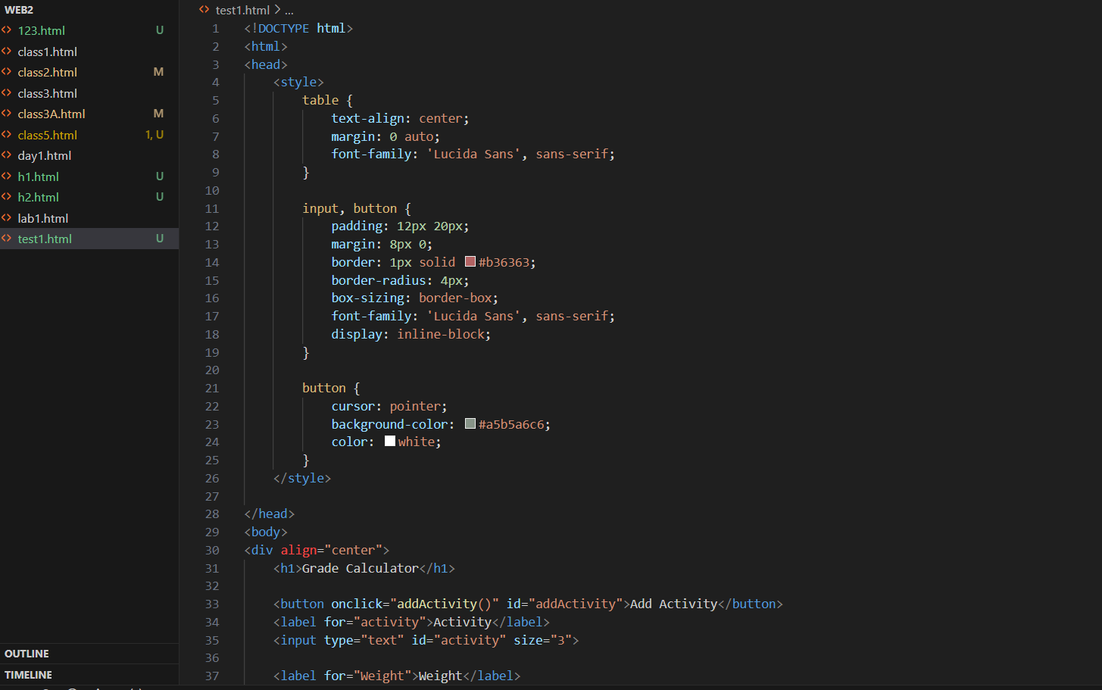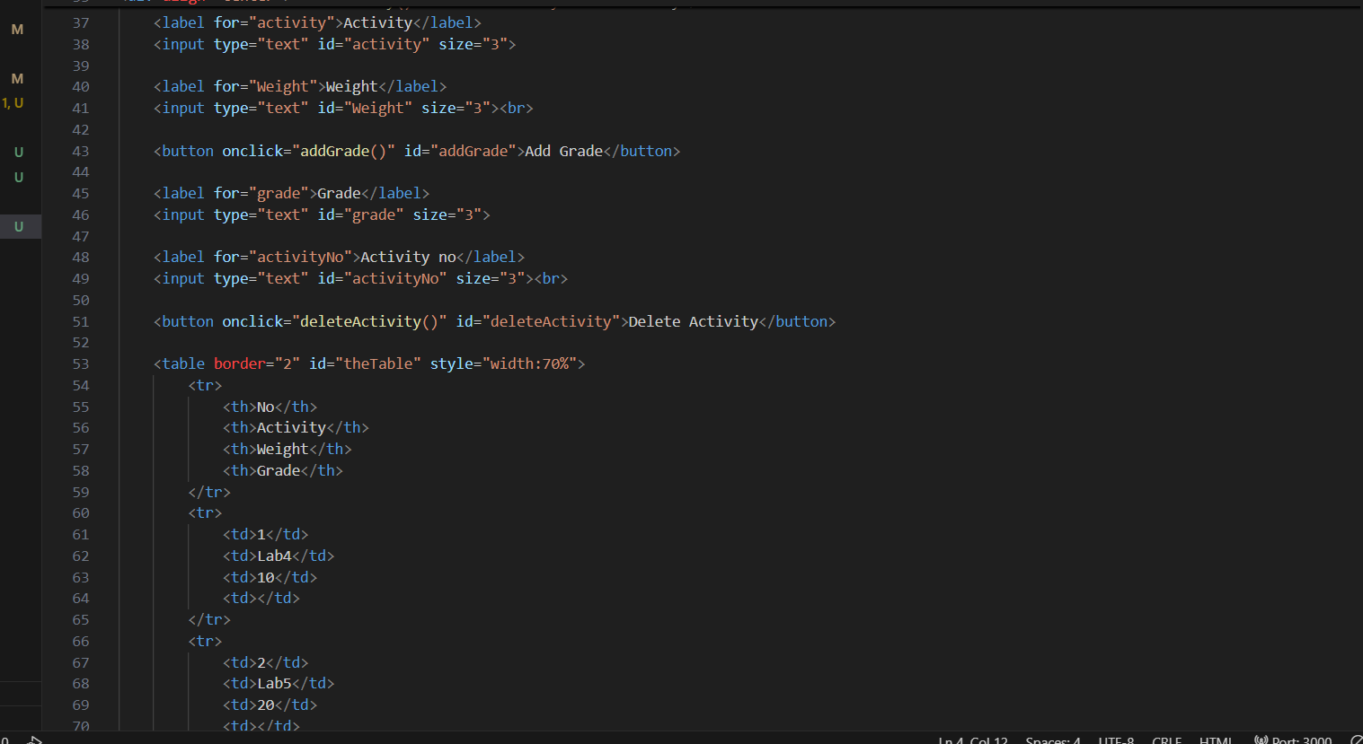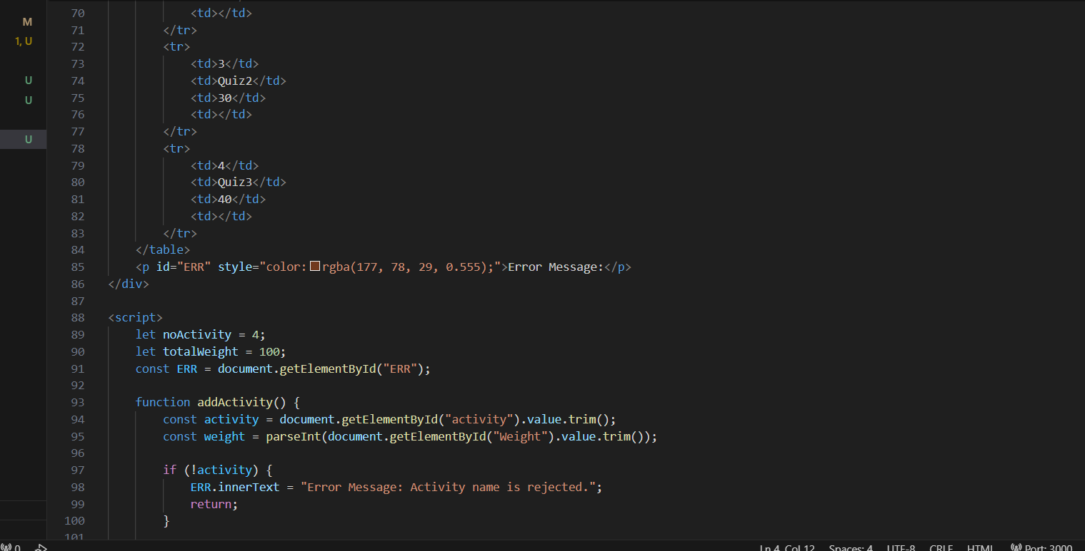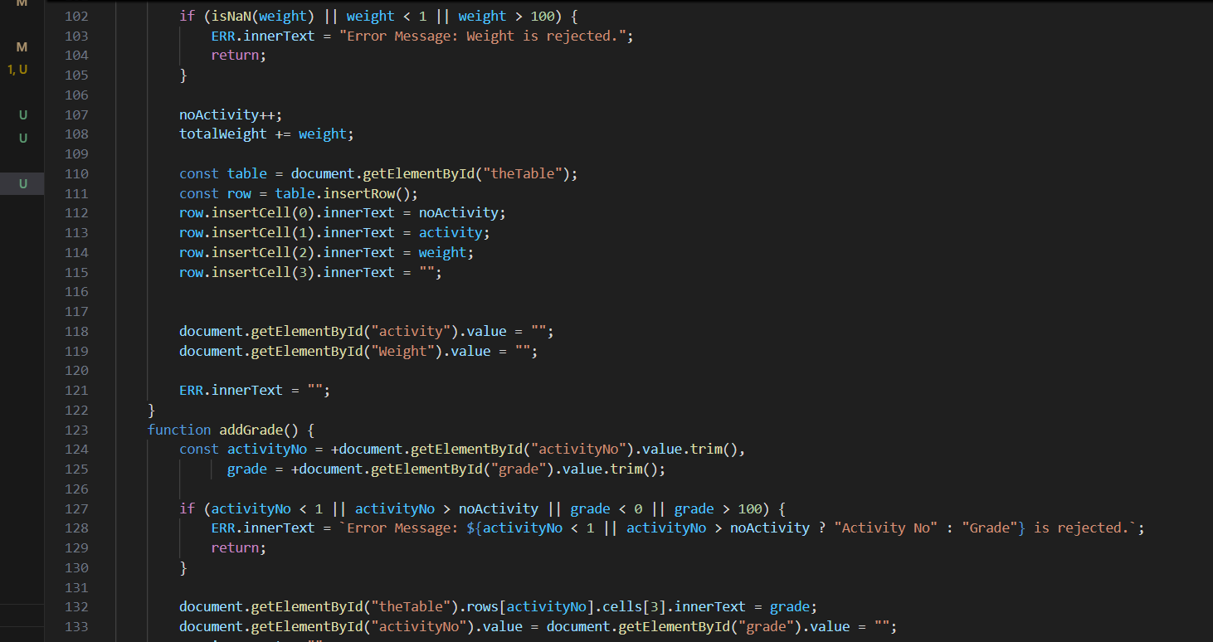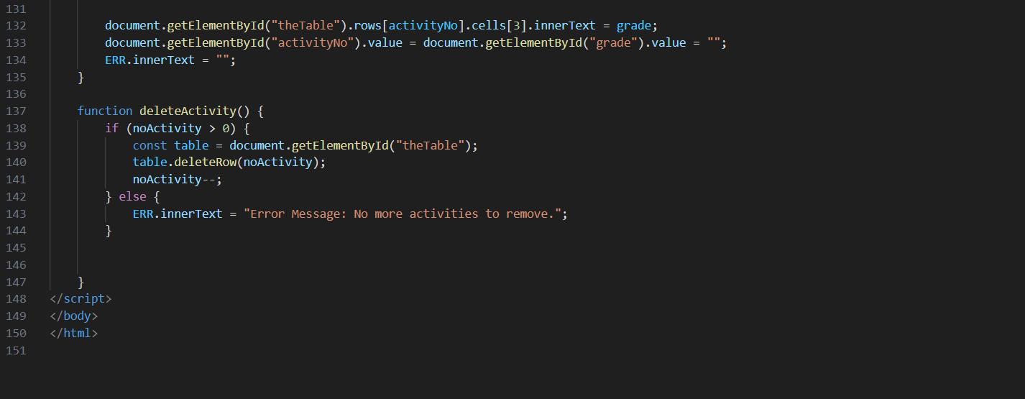

Figure 1

## **Assignment Steps-2**

Here is my output

1.

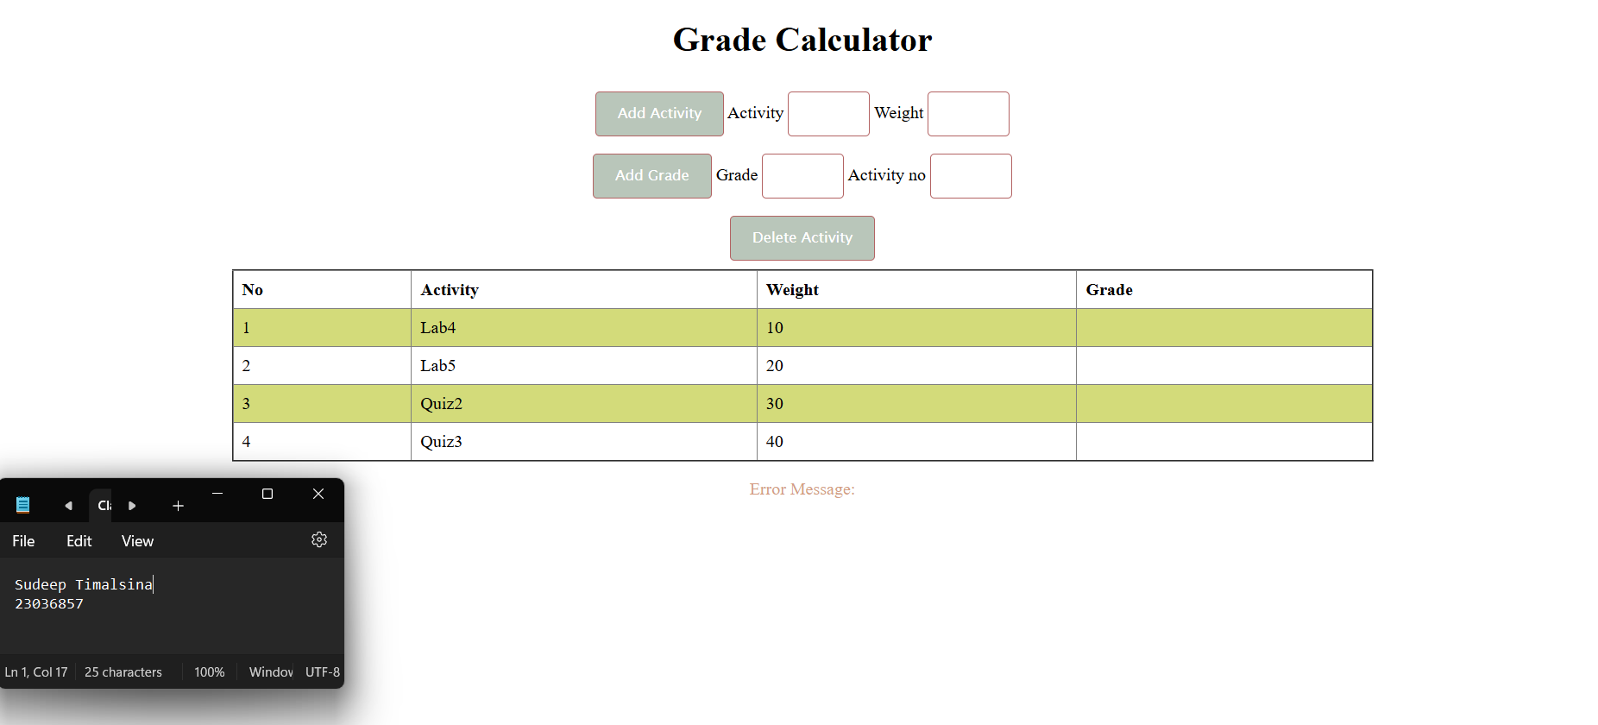

2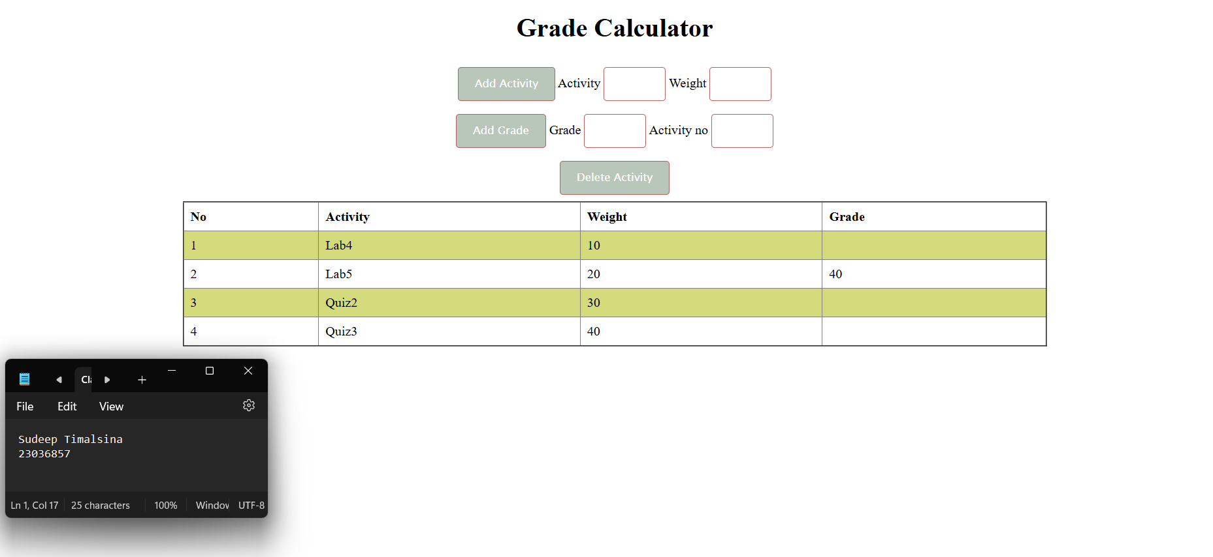

3.   If the Activity is empty, the result will be;

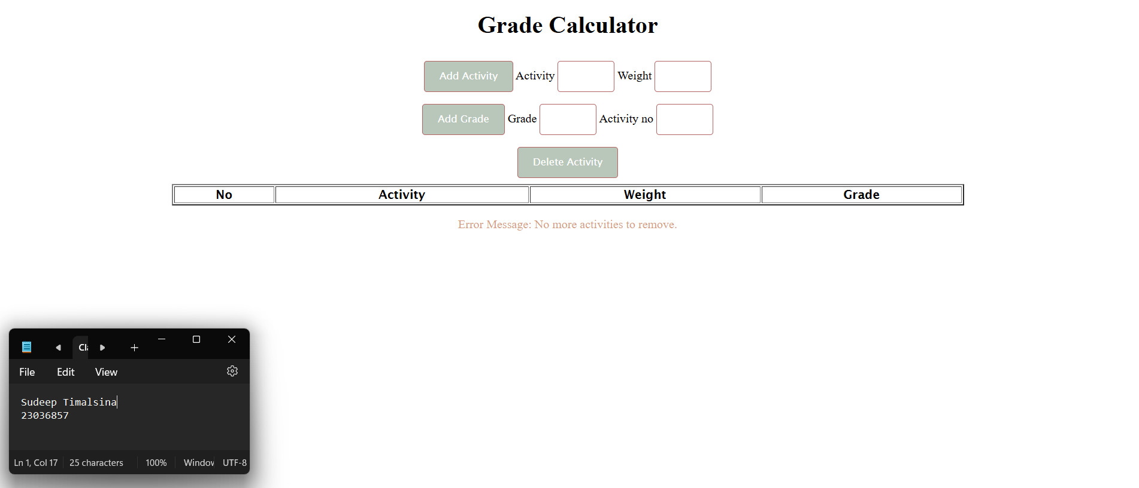

4.   If the Activity is empty, the error message is Error Message: Activity name is rejected. Here is my result;

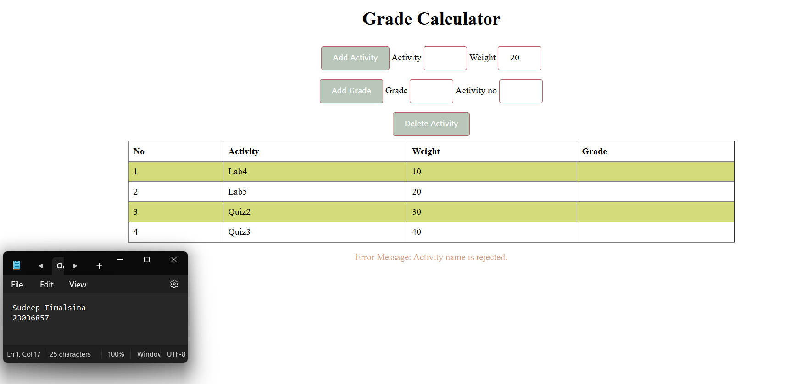

5. If the Weight is empty, or >100, or <1, the error message is Error Message: Weight is rejected. Here is my output for this instruction;

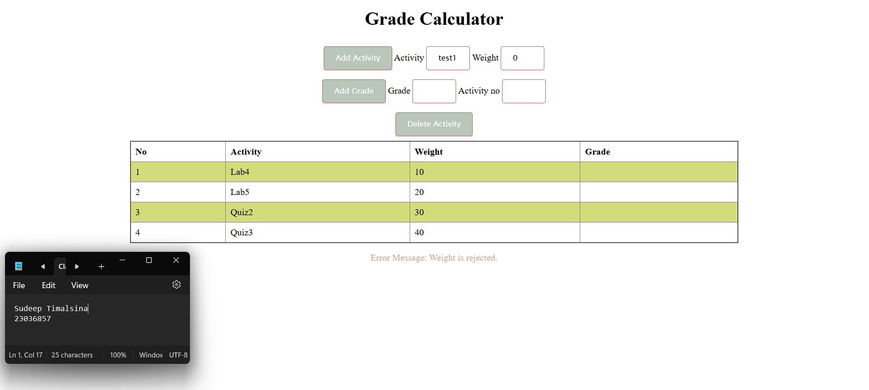

**Thank you.**